Activity 4: Effects of hazardous substances, water level regulation and climate change on the ecological condition on the of the River Pasvik and Inari Like

Trilateral Cooperation on Environmental Challenges in the Joint Border Area

UiT The Arctic University of Norway
Per-Arne Amundsen

This publication has been produced with the assistance of the European Union, but the contents of this publication can in no way be taken to reflect the views of the European Union.
7. The fish community of lakes in the Pasvik watercourse

Fish diversity
Altogether 15 different fish species have been recorded in the Pasvik watercourse, including European whitefish (Coregonus lavaretus), vendace (Coregonus albula), European perch (Perca fluviatilis), northern pike (Esox lucius), burbot (Lota lota), nine-spined stickleback (Pungitius pungitius), brown trout (Salmo trutta), European grayling (Tymallus thymallus), Eurasian minnow (Phoxinus phoxinus), Arctic charr (Salvelinus alpinus), three-spined stickleback (Gasterosteus aculeatus), Atlantic salmon (Salmo salar), pink salmon (Oncorhynchus gorbuscha), European eel (Anguilla anguilla), and Arctic lamprey (Lethenteron camtchaticum). The latter four are diadromous and are at present likely restricted to the short river stretch below the Boris Gleb dam construction, but their current status is poorly known. The Arctic lamprey may exist as a non-migratory form, but there are no record of its ecology and status in the watercourse. Also Arctic charr and three-spined stickleback may be restricted to anadromous populations below the Boris Gleb dam, but their status is unknown. These two species have not been caught in any lake samples from the watercourse over the last decades and are apparently not present in the main parts of the Pasvik watercourse, even though they occur upstream in e.g. Lake Inari.

Fish in the lake systems
Due to the establishment of several hydropower stations, the Pasvik watercourse is now completely dominated by lakes and reservoirs. The most important fish species in these lacustrine systems include whitefish, vendace, perch, pike, burbot, nine-spined stickleback, brown trout and grayling (Fig. 7.1, 7.2).

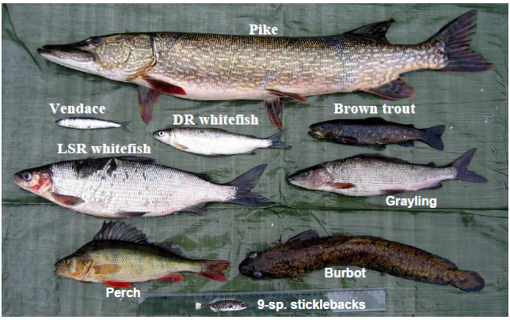
Fig 7.1 The main members of the fish communities in lakes in the Pasvik watercourse.

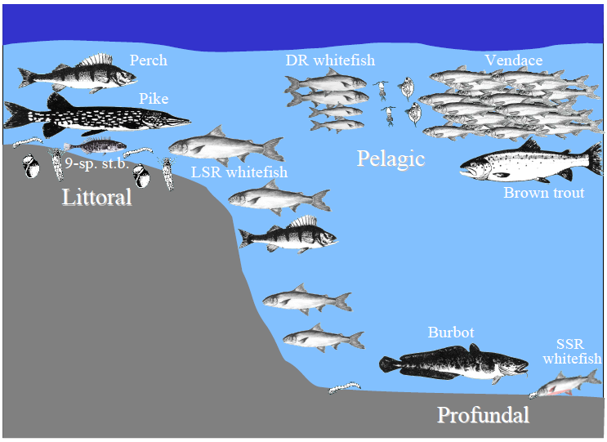
Fig 7.2 The principal habitat distribution of fish in lakes in the Pasvik watercourse.

Vendace invaded the Pasvik watercourse around 1990, after being introduced to Lake Inari in the 1960’s (Amundsen et al. 1999, 2012; Præbel et al. 2013a). This zooplanktivore specialist (Amundsen et al. 2009) has now become the dominant pelagic species in the watercourse (Bøhn et al. 2008; Sandlund et al. 2013). The occurrence of vendace in Pasvik represent the World’s northernmost population of this species.
Whitefish has been the most numerous fish species in the Pasvik watercourse, occupying all major lake habitats in high numbers (Fig. 7.2; Amundsen et al. 1999). The whitefish in the watercourse is polymorphic, consisting of three different morphs, differentiated in particular by their morphology and number of gill rakers, and referred to as small sparsely rakered (SSR), large sparsely rakered (SSR) and densely rakered (DR) whitefish (Siwertsson et al. 2010). The three morphs have large ecological differences; the LSR morph predominantly residing in the littoral zone feeding on littoral zoobenthos, the DR morph in the pelagic habitat feeding on zooplankton, and the SSR morph in the profundal utilizing typical profundal prey (Fig. 7.2; Kahilainen et al. 2011a). The morphs are genetically differentiated (Præbel et al. 2013b), and also differ in their main life-history parameters (Bøhn et al. 2004; Sandlund et al. 2013).
Perch is also numerous in the watercourse, mainly residing in the littoral zone and to some extent also utilizing the profundal (Fig. 7.2). The diet use of perch includes several ontogenetic niche shifts (Amundsen et al. 2003). Young-of-the-year perch predominantly feed on zooplankton and may also be found in the pelagic habitat, but at sizes >10 cm zoobenthos become the dominant prey. At this size, perch also start feeding on nine-spined stickleback, and at sizes around 20 cm the sticklebacks usually constitute the dominant prey. Other fish prey, in particular whitefish, also starts to occur in the diet at sizes around 15-20 cm, and whitefish is the dominant prey for perch larger than c. 30 cm (Amundsen et al. 2003, unpublished data).
Pike is typically found in the shallow littoral, but has in the latest years also more frequently been caught in the pelagic habitat. Also pike reveals ontogenetic niche shifts, but this specialized piscivore rapidly turns into feeding on nine-spined stickleback and other small fish (Amundsen et al. 2003). For pike >20 cm, whitefish is the dominant prey. However, following the invasion and establishment of large densities of vendace, this pelagic species has now also become an important prey fish for pike.
Burbot is a benthic dwelling fish species, residing in the littoral and profundal habitats. Small-sized burbot is predominantly feeding on zoobenthos, whereas fish prey dominate the diet of larger fish; first nine-spined stickleback and thereafter whitefish at sizes >20 cm (Amundsen et al. 2003). The abundance of burbot is low relative to e.g. perch and pike.
Nine-spined stickleback has a key role in the food web of the lacustrine ecosystems in the watercourse, being a dominant prey for the small to intermediate sized of predatory fishes, in particular perch and burbot (Fig. 7.3; Amundsen et al. 2003). The ecology of the nine-spined sticklebacks has, however, not been explored in detail. They may utilize both benthic and pelagic habitat and food resources, but stable isotope data and their prevalent presence in the stomachs of littoral-caught piscivorous fish indicate that they mainly reside in the littoral.
The brown trout in the Pasvik watercourse is a fast growing, typical piscivorous form, which mainly feed on coregonid prey (vendace and DR whitefish) in the pelagic (Jensen et. al. 2004, 2008). Juvenile trout reside in running water, especially in tributary rivers and streams (Amundsen et al. 2004), and enter the lacustrine parts of the watercourse when approaching 20 cm length at age 2-3 years. The hydropower regulations in the Pasvik watercourse have chiefly reduced the spawning and nursery areas for brown trout, and the Norwegian hydropower company (Pasvik Kraft ASA) is therefore carrying out a mandatory annual stocking of brown trout to compensate for the reduced reproduction and recruitment possibilities.
Grayling has suffered from the hydropower regulations due to the loss of stretches with running water. The species is now only occasionally present in gill net samples from lakes in the watercourse, but may occur more commonly on riverine stretches.

Food web structure
The food web of the lake ecosystems in the watercourse consist of two main compartments originating from the pelagic and benthic primary production, respectively (Fig. 7.3). In the native ecological community, the two most common whitefish morphs, DR and LSR whitefish, have central roles in each of these compartments; the DR morph utilizing the zooplankton resources and the LSR morph the benthic invertebrates, mainly in the littoral zone (additionally the less abundant SSR morph is utilizing the benthic invertebrates in the profundal). Following the invasion of vendace, this non-native species has now become the key zooplankton predator and a dominant fish species in the pelagic habitat. Brown trout is the key top predator in the pelagic compartment, feeding predominantly on vendace and DR whitefish. In the benthic part of the trophic network, adult perch, burbot and pike are piscivorous species utilizing in particular nine-spined stickleback and whitefish as prey. Large-sized pike also includes perch, burbot and smaller pike in the diet and is thus the top predator in the benthic food-web compartment. However, pike is now also feeding extensively on the abundant vendace population and may occasionally even consume brown trout. Pike therefore constitutes the apex predator of the whole aquatic network in the Pasvik watercourse (Fig. 7.3). Also perch and burbot have recently started to include vendace in their diet, and the separation of the pelagic and benthic food-web compartments has therefore become less pronounced after the vendace invasion in the watercourse. Nine-spined stickleback has a central role in the trophic network, apparently constituting a dietary stepping stone for the benthic piscivorous to become large enough to be able to start feeding on whitefish (Amundsen et al. 2003).

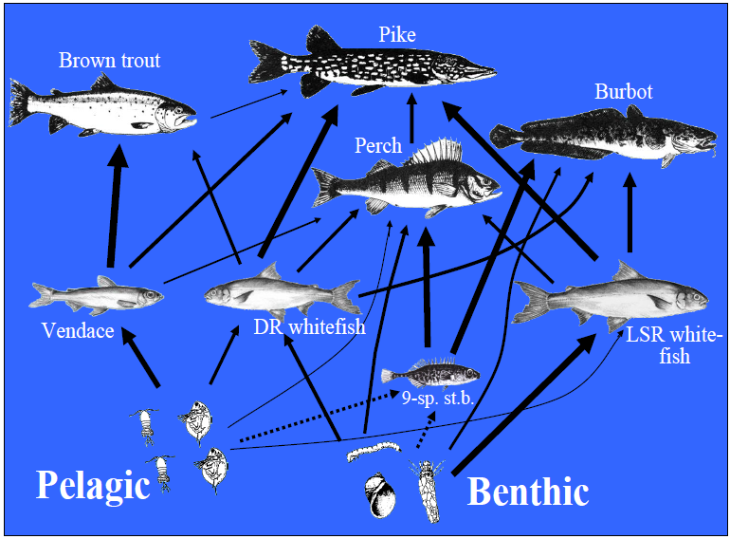
Fig. 7.3 Summary of the basic food web structure of the lacustrine fish communities in the Pasvik watercourse (line thickness indicates the importance of the different links. Stippled lines represent unconfirmed links).

Stable isotopes
Stable isotope analysis is an important complement to traditional habitat and diet analyses providing long-term integrated information about the main nutritional sources, thereby constituting a cost-effective tool to explore the trophic ecology of freshwater organisms and the food-web structure of aquatic ecosystems (Boecklen et al. 2011; Layman et al. 2012). The carbon and nitrogen stable isotope ratios (expressed as δ¹³C and δ¹⁵N, respectively) can distinguish between resources from the three principal lake habitats; littoral, pelagic and profundal (Vander Zanden and Rasmussen 1999; Syväranta et al. 2006). Littoral and pelagic resources typically differ in baseline isotopic values since pelagic phytoplankton are depleted in δ¹³C compared to benthic algae (Vander Zanden and Rasmussen 1999). Profundal areas are often dominated by the detritus food chain, which gives more enriched δ¹⁵N due to the accumulation of the heavier isotope in consumers compared to their prey (e.g. Vander Zanden and Rasmussen 1999; Post 2002). The nitrogen isotope ratios can furthermore be used to estimate the trophic position of a species as there generally is a trophic enrichment of δ¹⁵N by around 3–4 ‰ per trophic level (Post 2002).

A summary plot of the mean carbon and nitrogen stable isotope ratios for key taxa in the Pasvik lakes food webs reveals a distinct pattern of trophic levels and resource utilization (Fig. 7.4), chiefly reflecting the trophic network established from habitat use and stomach contents data (Fig. 7.3). Along the δ¹⁵N-axis, the invertebrates are positioned at lower values, which reflect their low positions in the trophic network. The profundal invertebrates (here represented by profundal chironomids) do, however, show the typical elevated δ¹⁵N-levels as compared to the littoral and pelagic invertebrates, a pattern that is also reflected in the relatively high δ¹⁵N-levels of the profundal dwelling, invertebrate-feeding SSR whitefish. Invertebrate-feeding fish species from the pelagic and littoral habitats like e.g. the other coregonids and nine-spined stickleback dominate the intermediate δ¹⁵N-levels, whereas piscivorous species like brown trout and in particular pike are positioned at the highest trophic levels as indicated by their high δ¹⁵N-values (Fig. 7.4). Perch is positioned intermediate to the coregonids and pike, reflecting their more omnivorous diet consisting both of invertebrate and fish prey. Along the δ¹³C-axis, the profundal and pelagic invertebrates (chironomids and zooplankton, respectively) have lower values than the littoral invertebrates (snails and littoral chironomids). Similarly for the coregonid species, vendace and SSR whitefish utilizing pelagic and profundal resources, respectively, are positioned towards lower δ¹³C-values than the predominantly littoral dwelling LSR whitefish. Among the top predators, brown trout, which typically feed in the pelagic habitat, had somewhat lower δ¹³C-values than pike (Fig. 7.4).

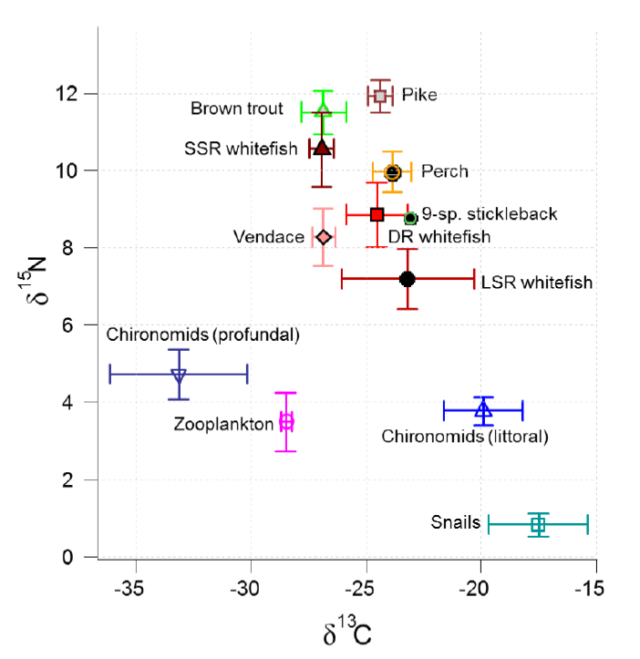
Fig. 7.4 Mean stable isotopes ratios (δ¹³C and δ¹⁵N) of important taxa in the lacustrine food webs of the Pasvik watercourse (data mainly from Vaggatem).

8. Long-term effects of metal contaminations, water regulations, species invasions and climate change on the ecological condition in the Pasvik watercourse

Background
The Pasvik watercourse has rich natural resources with a high diversity and production of aquatic organisms, including a highly valuable freshwater fish fauna that is important for e.g. recreational and subsistence fishery. However, the watercourse also suffers from a number of anthropogenic impacts that potentially may have large ecological consequences. The multitude of stressors encompasses chemical, physical and biological factors, in particular represented by large pollution outputs from metallurgic smelters, extensive water regulations, introduction and invasion of non-native species, compensatory fish stockings, and unregulated and unrecorded fish exploitation. Over the latest decades, an additional stressor has arisen due to the current global warming scenario, which also is likely to have most dramatic effects on ecosystems that already are under severe stress by other factors. In relation to these extant threats and in order to enhance the general knowledge of subarctic freshwater ecosystems in this region, the fish communities of lakes in the Pasvik watercourse have been subject to extensive long-term biological studies with annual sampling since 1991; mainly carried out by the University in Tromsø, partly also in collaboration with INEP, Kola Science Centre. The principal lakes for these long-term studies are Skrukkebukta and Vaggatem. Additionally, the fish communities in Kuetsjavri and (to a less extent) Rajakoski have been explored over time, but at less frequent annual occasions. As a part of the TEC project, material and data from these long-term studies have been addressed and analyzed in order to explore temporal changes related to the most severe factors impacting the watercourse, emphasizing in particular metal contaminations, water regulations, species invasions and climate change effects on the fish communities.

Heavy metal contaminations in fish
To explore the heavy metal contents in fish in the Pasvik watercourse and to reveal any temporal changes in the contamination levels, several elements have been analyzed in different tissues from six fish species and at three different sites, covering four sampling periods over the time span from 1991 to 2013 (Period 1 – 1991-1992; Period 2 – 2002-2005; Period 3 – 2007-2008; Period 4 – 2012-2013). The studied lakes are Kuetsjarvi, Skrukkebukta and Vaggatem. Some additional samples are also available from Rajakoski (Period 2 and 4) and Lake Inari (Period 2). Fish species addressed in these studies are DR and LSR whitefish, perch, pike, brown trout and vendace, and tissue samples have been retrieved from muscle, liver, gills, kidney and skeleton. Elements that have been examined in all sampling periods include nickel (Ni), copper (Cu), cadmium (Cd), chromium (Cr), zinc (Zn) and mercury (Hg) (see Amundsen et al. 1997, 2011 and Kashulin et al. 2011 for details about field sampling and analytical methods).

A temporal analysis of the Ni contents in different tissues of the DR and LSR whitefish morphs revealed no distinct variations throughout the four time periods from 1991 to 2013 (Fig. 8.1; although some significant differences were observed, no consistent temporal patterns could be identified across two or more localities, species or tissues). A profound and significant decline in contamination levels with increasing distance from the smelters (i.e. from Kuetsjarvi to Skrukkebukta to Vaggatem) was, however, evident for all the examined time periods (see Fig. 8.1 a, b, and c; upper and lower panels). This could also be seen for the Ni contents in different tissues of perch and pike (Fig. 8.2). Similar patterns were also revealed for Cu and Cd: occasionally some significant differences between time periods could be observed, but no consistent temporal pattern could be revealed across localities, species or tissues, whereas there was a declining spatial trend with increasing distance from the smelters. Also for the tissue contents of Cr and Zn, there were no distinct variations through time. Hence, for none of these elements any major changes in the contamination levels in fish tissue appear to have occurred over the time period from 1991 to 2013.

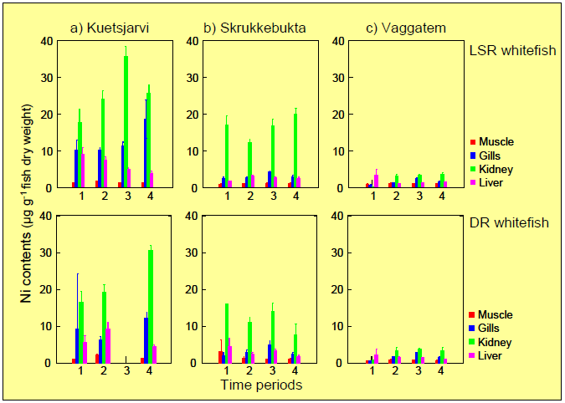
Fig. 8.1 Temporal changes in Ni contents in DR and LSR whitefish in a) Kuetsjavri, b) Skrukkebukta and c) Vaggatem.

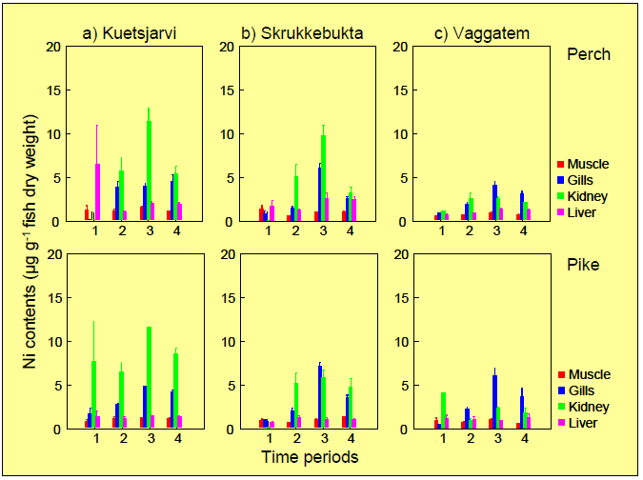
Fig. 8.2 Temporal changes in Ni contents in perch and pike in a) Kuetsjavri, b) Skrukkebukta and c) Vaggatem.

In contrast, for the mercury (Hg) contents in fish tissues a distinct temporal pattern was evident. Both in Kuetsjarvi (Fig 8.3a) and Skrukkebukta / Vaggatem (Fig. 8.3b) there were for most fish species a significant increase in the Hg contents in muscle tissue over the four sampling periods from 1991 to 2013. Similar patterns were observed for the Hg levels in liver, gills and kidney, reflecting a strong correlation between the Hg contents of different tissue types within each individual fish. The increase in Hg contamination over the study period was particularly large for the predatory species (i.e. brown trout, perch and pike), and less distinct for the coregonids. In Kuetsjarvi, there was a slight decrease in the Hg level in most fish species from Period 1 to 2 (see also Amundsen et al. 2006), followed be a large increase towards period 3 and 4, especially for perch and pike (Fig. 8.3a). In Skrukkebukta and Vaggatem, there was for most fish species a continuous increase in the Hg level throughout the study period from 1991 to 2013, with particularly high contamination levels observed in Period 3 and 4, especially for brown trout, perch and pike (Fig. 8.3b). The generally higher contamination levels in these predatory species than in the coregonids are to be expected as Hg is an element that accumulates in organisms and thus typically increases with increasing trophic levels within the food webs (see Fig. 7.3 and 7.4 for the trophic positions of the different fish species). Similarly, the Hg contents in fish also tend to increase with increasing fish size, which could be seen for brown trout, perch, pike, and LSR whitefish (Fig. 8.4a,b,c,d), but was not evident for DR whitefish and vendace which have more narrow size ranges (Fig. 8.4e,f).

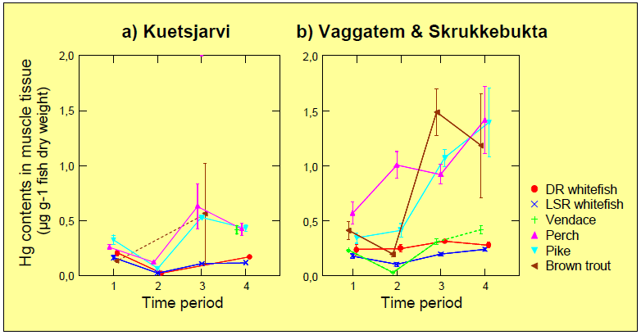
Fig. 8.3 Temporal changes in Hg levels in muscle tissue of fish from a) Kuetsjarvi and b) Skrukkebukta & Vaggatem (samples from these two lakes were combined to strengthen the observation numbers as no large differences in Hg levels were evident between these two localities).
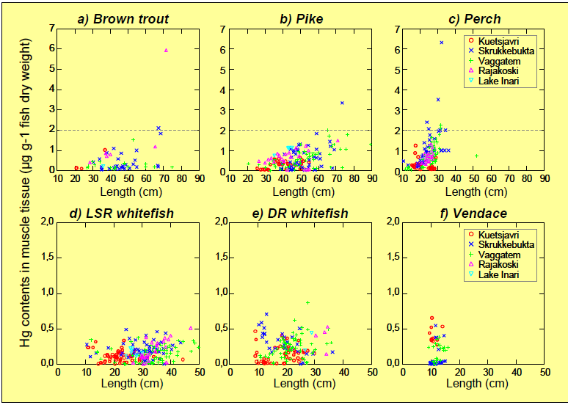
Fig. 8.4 Hg contents relative to fish size in a) brown trout, b) perch, c) pike, d) LSR whitefish, e) DR whitefish, and f) vendace.

For Hg, the critical limit for human consumption is both in EU and Norway and Russia set to 0.5 μg g⁻¹ wet weight (equivalent to approx. 2 μg g⁻¹ dry weight). For most fish, the observed Hg levels in the muscle tissue were below the critical limit for human consumption, but for some specimens of brown trout, pike and perch the critical limit was notably exceeded. The highest Hg levels were observed in a perch (6.33 μg g⁻¹ dry weight) and a pike (3.34 μg g⁻¹ dry weight) caught in Skrukkebukta, and in a brown trout (5.96 μg g⁻¹ dry weight) caught in Rajakoski; all three being caught in period 4 (2012-13). These high levels and the distinct increase in Hg levels in fish over the latest decade may suggest that the contaminant inputs from local and/or global sources have chiefly increased in recent years, but this suggestion is not supported by other studies (e.g. Riget et al. 2011; Castello et al. 2013). An alternative and more plausible explanation is related to the ongoing global climate changes. Increased temperatures and a higher run-off of water due to increased precipitation have already been demonstrated for the watercourse (see Fig. 8.10 and 8.12). This has likely resulted in a more extensive wash-out of pollutants from the large catchment area and into the watercourse, where biomagnification and accumulation of Hg through the food web rapidly may result in elevated contamination levels in the top predators (conf. e.g. Harris et al. 2007). The further developments in the Hg contamination levels in fish should be closely monitored as the present situation is disturbing and unresolved. The possible role of climate change impacts also needs further scrutiny.

Water regulations
There are altogether seven dam constructions for hydroelectric purposes along the 145 km long waterway of the Pasvik watercourse from the outlet of Lake Inari to the sea entry in Bøkfjorden. The hydropower stations were constructed in the period from 1951 to 1978 (Table 8.1). Following the establishment of these power stations, there have been large changes in the physical characteristics of the watercourse. More specifically, as the water levels increased due to the water impoundments, large areas were flooded, previous rapids and waterfalls disappeared, and the former river system is now dominated by consecutive lakes and reservoirs. The hydropower developments and utilization in the Pasvik watercourse are regulated by a joint agreement between Finland, Norway and Russia, and the regulation and flow schemes of the seven power stations are strongly coordinated, partly in order to minimize any negative impacts due to the present-day power production. Hence, the current water level fluctuations (= vaihtelu) are moderate, usually being less than 80 cm on an annual basis and thus at the level of the natural fluctuations of the watercourse. The main negative biological impacts of the water regulations and impoundments are therefore related to the immediate changes in the physical characteristics of the watercourse that followed after the establishments of the dam constructions. In particular, principal spawning, nursery and feeding areas for brown trout and grayling were severely degraded and reduced due to the disappearance of the riverine stretches of the watercourse, resulting in strong declines in the abundance of these species (Kristoffersen 1984; Arnesen 1987). Furthermore, the large physical changes of the watercourse have benefitted typical lake-dwelling fish species like whitefish, perch and pike, especially through the development of large reservoirs. Moreover, the establishment of the dam constructions has resulted in a fragmentation of the watercourse, making upstream fish migration impossible and downstream migration infeasible. The most dramatic effect in this respect is that anadromous (= lives in the sea, breeds in fresh water) fishes, in particular Atlantic salmon, have lost access to the watercourse above the Boris Gleb dam construction with detrimental consequences for these fish populations (Bjerknes & Rikstad 1977; Bøhn & Johansen 2003). For the resident fish populations in the watercourse, the fragmentation and migration limitations may have resulted in some genetic constraints for some of the fish populations, but this has yet not been explored.

Table 8.1: Overview and information about the hydropower stations in the Pasvik watercourse.

Power station | Year established | Effect | Average annual  production | Turbines | Country
Kaitakoski | 1959 | 11 MW | 69 GWh | 2 | Russia
Janiskoski | 1951 | 31 MW | 208 GWh | 3 | Russia
Rajakoski | 1956 | 43 MW | 228 GWh | 3 | Russia
Hevoskoski /Hestefoss | 1970 | 47 MW | 215 GWh | 2 | Russia
Skogfoss | 1964 | 60 MW | 258 GWh | 2 | Norway
Melkefoss | 1978 | 26 MW | 129 GWh | 1 | Norway
Boris Gleb | 1963 | 56 MW | 272 GWh | 2 | Russia

Brown trout stocking
The Pasvik brown trout has some unique characteristics, being one of a few predominantly piscivorous, fast-growing and large-sized brown trout populations occurring in northern Fennoscandia. Due to the negative effects of the impoundments on the recruitment potential of brown trout in the watercourse, the local Norwegian hydropower company is carrying out an imposed annual stocking of 5000 large-sized trout. Before stocking, these fishes are reared for 2-3 years in aquaculture facilities in the Skogfoss hydropower station, and the brood stock consists of Pasvik trout that are collected locally. The stocked brown trout are distributed along the watercourse from Hestefoss to Skrukkebukta. The brown trout stocking was initiated in 1979. In the period 1979-1984, approx. 2000 trout >20 cm were stocked annually, and from 1985-1989 these annual stockings were increased to 5000 trout per year. From 1990 the minimum size was increased to 25 cm, and thereafter an annual stocking of approx. 5000 trout >25 cm has been carried out.

The brown trout population was monitored regularly from 1998 – 2008 and less intensively over the latest years, mainly based on samples retrieved from the catches of local fishermen. Tagging experiments in relation to the brown trout stockings were also carried out in 1999, 2004 and 2009 (see e.g. Jensen et al. 2006). Due to an absent reporting system for the fishermen’s catches, it has not been possible to implement any estimates of catch rates, mortality rates or the variation in population density of brown trout. The studies have, however, documented that the trout stockings are important for the present brown trout population as stocked fish comprise >80% of the total catches. The contribution of wild trout in the catches has been slightly higher in the upper part of the watercourse (mainly Vaggatem area), with an average frequency of 81.8% stocked fish relative to 90.1% in the lower part (mainly Skrukkebukta area). From 1998 to 2008, the contribution of stocked fish has distinctly decreased in the catches in the lower part, whereas there has been a more modest decrease in the upper part (Fig. 8a). In other words, the contribution of wild trout in the catches has increased, which suggests that the natural production of brown may have slightly improved, possibly as a result of a larger spawning population due to the contribution of stocked fish. Vendace has been the dominant prey both for stocked and wild brown trout over this time period, with an increasing dietary contribution from around 75% in 1998 to nearly 100% in 2008 (Fig. 8b). Hence, the vendace invasion and the establishment of a high population abundance of the invader have provided a new prey source for the piscivorous trout, and may thus have increased the production potential of brown trout in the watercourse. Informal information from fishermen suggests that the brown trout catches have increased over the last decades, but this may also be related to increased interest and efforts for brown trout fishing. Due to the lack of any official records of the brown trout catches in the watercourse, the knowledge is insufficient and the current population status thus partly uncertain. The trout stockings are apparently important for the maintenance of a decent population level, but possible long-term consequences of these fish stockings have not been assessed. The strategy for the stocking program appears good, especially in respect to the exclusive use of brood fish from the local trout population. However, artificial selection may occur during the collection of the brood stock and subsequently in the breeding and rearing facilities, potentially leading to a reduced genetic diversity. Further studies of the brown trout population should therefore be implemented, including a genetic survey. Moreover, the remaining spawning and nursery areas for brown trout in tributary streams need particular attention and protection, especially since the trout has an obligate role in the life-cycle of the red-listed freshwater pearl mussel Margaritifera margaritifera (e.g. Aspholm 2013).
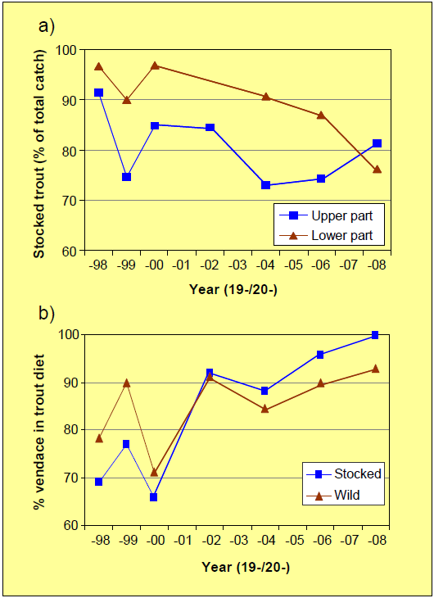
Fig. 8.5 a) The contribution of stocked trout in the total brown trout catches form the upper and lower part of the watercourse, and b) the diet contribution of vendace in wild and stocked brown trout in the Pasvik watercourse from 1998 to 2008.

Vendace invasion
Introductions and invasions of non-native species is a problem of global extent, and the adverse effects that often follow may have negative consequences both for biodiversity conservation, nature management, and the exploitation of natural resources (Sandlund et al. 1999, Mooney and Hobbs 2000). Unforeseen effects may also commonly occur, and biological invasions should therefore be carefully monitored in order to address potential problems that may arise. The negative consequences of introductions and invasions have in recent decades been met by international agreements aimed at reducing the spread of exotic species (e.g. WRI/IUCN/UNEP 1992). However, when new introductions accidentally occur, strong efforts should be made to extract as much information as possible from the event in order to enhance the general knowledge of species invasions and their ecological impacts.

The invasion of vendace in the Pasvik watercourse had its origin from Lake Inari, where the species was introduced in the headwaters on two occasions in the 1950s and -60s (Mutenia and Salonen 1992). Recent genetic studies have revealed that repeated translocation of vendace in 1964-66 from Lake Sinettäjärvi in central Finland to a small lake in the catchment area of Lake Inari is the source for the invasion (Præbel et al. 2013). Vendace were observed for the first time in Lake Inari in 1973. By the early 1980s, a vendace population had established throughout the lake (Mutenia and Salonen 1992), increasing to a peak abundance in 1989 when also a large-scale vendace fishery had been established in Lake Inari (Salonen 1998; Salonen 2004). During this period a downstream invasion of vendace occurred into the outlet river, the Pasvik watercourse, where it was recorded for the first time in the upper reaches in 1989. The species was thereafter found in Vaggatem in 1991, had reached Skrukkebukta by 1993, and was by 1995 apparently present along the whole watercourse (Amundsen et al. 1999). The vendace invasion in the Pasvik watercourse was highly successful with a rapid population increase following colonization and establishment (Bøhn et al. 2008), apparently due to the adaptation of a successful pioneer life-history strategy based on characteristic r-selected traits such as early maturation and large reproductive investments (Amundsen et al. 2012). Within few years the invader became an important pelagic fish species in lakes in the Pasvik watercourse (Amundsen et al. 1999, Bøhn et al. 2004, 2008). However, the vendace population also entered a typical fluctuating ‘boom-and-bust’ development with large variations in population density (Salonen et al. 2007, Sandlund et al. 2013), resulting in a highly variable and unpredictable ecological situation in the watercourse.

In Vaggatem the vendace population rapidly increased in abundance after its arrival in 1991 and had by 1998 attained a peak density in the pelagic habitat (Fig. 8.6a). However, over the next couple of years there was an abrupt decline in the vendace density, which stayed low until 2003. A rapid increase followed from 2003 to 2004, but not to the same peak level as in 1998. In the following decade, the vendace density has shown large fluctuations with mainly three years intervals between peaks (Fig. 8.6a).

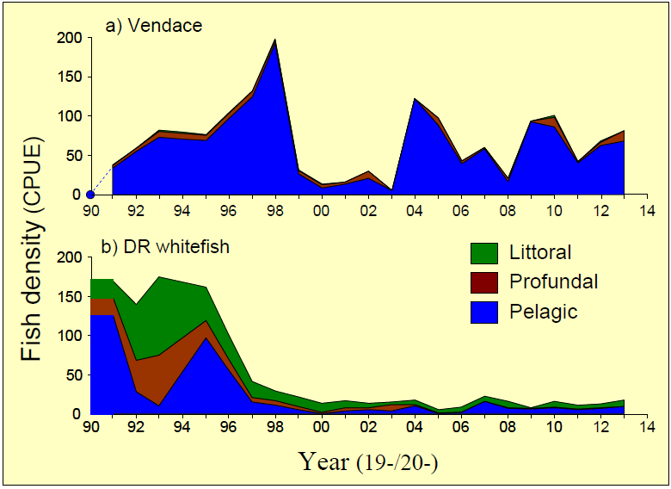
Fig. 8.6 Density developments of vendace and DR whitefish in Vaggatem in the time period from 1991 to 2013.

The invasion and rapid population increase of vendace in Vaggatem had an immediate and dramatic effect on the DR whitefish population (Fig. 8.6b). Over the first 3-4 years, the total density of DR whitefish remained at a constant level. However, only one year after the arrival of vendace a major behavioral shift occurred, where most of the DR whitefish population disappeared from its preferred habitat, the pelagic, and was relegated into the littoral and profundal habitats as a response to the vendace invasion. This situation was maintained for a few years, but after 1995 a dramatic decline occurred in the DR whitefish abundance (Fig. 8.6b). From 1998 and onwards to 2013, the density of DR whitefish has constantly been <20% and on average only 9% of the initial density at the time when the vendace arrived. Even during the period from 2000-2003 when the vendace density seemingly was at low levels, no apparent rebuild of the DR whitefish population occurred.

Vendace is a specialist zooplankton predator that is highly adapted to live and feed in the pelagic habitat. Among the whitefish morphs in the Pasvik watercourse, the DR whitefish represents the zooplanktivore specialist having the pelagic zone as its preferred habitat (Bøhn & Amundsen 1998, 2001). The closely related vendace is however a superior zooplankton predator, having numerous dense and long gill rakers that are highly suitable for retaining and eating small zooplankton (Kahilainen et al. 2011). Hence, the vendace is a stronger competitor for zooplankton as it can utilize this resource more efficiently than the DR whitefish (Bøhn & Amundsen 2001). The strong ability of vendace as a zooplankton predator is clearly documented from the long-term changes in zooplankton density following the vendace invasion (Fig. 8.7). Within the first decade after the vendace invasion in Vaggatem, the zooplankton density was strongly diminished, and from year 2000 and onwards the total zooplankton density has been <25% (mean 16%) of the initial level at the arrival of vendace in 1991. The size of cladocerans like Daphnia spp. and Bosmina spp. has significantly decreased due to the efficient vendace grazing (Amundsen et al. 2009), and a few larger-sized cladoceran species appear to have disappeared from the zooplankton communities at sites with particularly high vendace densities. As a result, the zooplankton resource appears to be inaccessible as a significant dietary source for DR whitefish when vendace is present in high densities. Even the vendace itself suffers from the strongly diminished zooplankton resources as their somatic growth rate is very poor (Amundsen et al. 2012; Sandlund et al. 2013). Moreover, at the lowest recorded zooplankton densities in Vaggatem in 2008, the vendace was observed to feed on highly untypical food types such as benthic invertebrates and even fish prey (nine-spined stickleback; Liso et al. 2011). Thus, the relegation of DR whitefish from the pelagic habitat in Vaggatem is a result of strong interspecific competition from vendace and highly diminished zooplankton resources. The large decline in the DR whitefish population following the switch to the benthic habitats is however mostly explained by high predation rates from the benthic piscivores; pike, perch and burbot (Amundsen et al. 2003, Bøhn et al. 2008), especially since the more slowly growing DR morph is exposed to fish predation in the benthic habitats over a much longer time span than the fast-growing LSR morph (Bøhn et al. 2002).
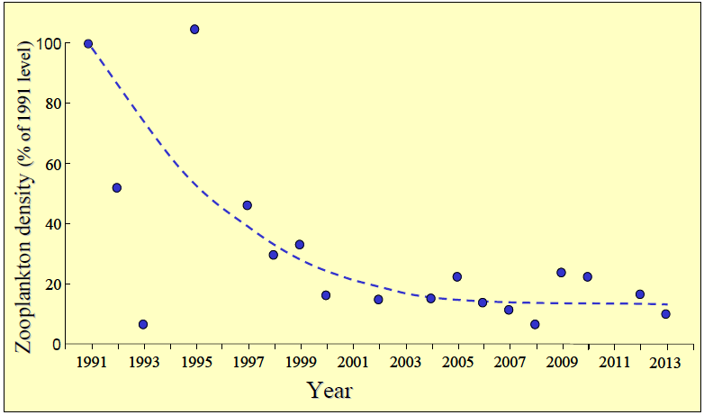
Fig. 8.7 Developments in total zooplankton densities (with fitted trend line) in Vaggatem following the vendace invasion in 1991. Density values are plotted in percent of the 1991 level.

The rapid population increase and pelagic dominance of vendace have in particular been profound in Vaggatem in the upper part of the watercourse, where vendace has constituted >80% of the total fish catch in most years since 1997 (Fig. 8.8). In Skrukkebukta in the lower part of the watercourse, the vendace arrived a few years later (1993), increased in population density and remained at a proportion of 30-40 % of the pelagic catches during the time period up to 2002, subsequently followed by an increase to a pelagic contribution mainly ranging between 40 and 60 % over the last decade (Fig. 8. 8). In Kuetsjarvi, the first observations of vendace occurred in 1995, but the contribution to the pelagic catches has never exceeded 20%. Assumedly these differences between localities are related to a variable resistance towards the invading species between sites and among fish communities of different structure and dynamics. In particular, the DR whitefish populations in Skrukkebukta and Kuetsjarvi consist of smaller-sized individuals and have a shorter generation time than in Vaggatem, which may make them more capable of responding to the competitive impacts of the invading vendace. In Kuetsjavri, local adaptations to the heavy pollution impacts by the whitefish populations may also have made it more difficult for the invading vendace to get an upper hand in competition and establish in high densities. Furthermore, at the time of the invasion the propagule pressure was likely much larger in the upper parts of the watercourse, which may have led to an abrupt shift in competitive and numerical dominance in favor of the vendace. This is supported by the rapid population increase of vendace and the abrupt habitat shifts of the DR whitefish following of the vendace invasion in Vaggatem (Fig. 8.6).

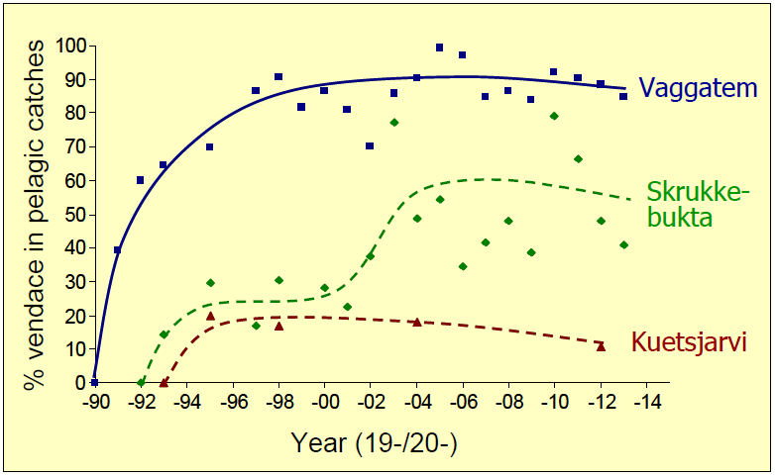
Fig. 8.8 The contribution of vendace in pelagic fish catches in Vaggatem, Skrukkebukta and Kuetsjavri in the period from 1991 to 2013.

Genetic impacts of the vendace invasion
The invasion of a new species that is taxonomically related to one of the native species opens the possibilities for hybridization to occur. Vendace and whitefish are sibling species belonging to the same genus (Coregonus), and hybridization between the two species is therefore plausible. In fact, in lake localities near Lake Inari, hybridization between native whitefish and the introduced vendace has already been documented (Kahilainen et al 2011b). A similar hybridization between vendace and whitefish has so far not been revealed in the studied lakes in the Pasvik watercourse. In contrast, a breakdown of the reproductive isolation between the LSR and DR whitefish morphs is documented to have occurred following the invasion of vendace (Bhat et al. 2014). These whitefish morphs represent incipient steps in an evolutionary process that eventually may result in the formation of new species (Siwertsson et al. 2010; Præbel et al. 2013; Evans et al. 2014). However, in this early phase of the speciation process, the reproductive isolation developed between the morphs is limited and fragile. Apparently the vendace-induced ecological displacement of the DR whitefish morph from its preferred pelagic niche to the benthic habitat harboring the LSR morph, has led to an increased rate of hybridization between the two morphs. From a detailed genetic investigation of these two whitefish morphs in Skrukkebukta based on samples collected at the arrival (1993) and 15 years after (2008) the vendace invasion, it was revealed that the frequency of hybrids had increased from 34% in 1993 to nearly 100% by 2008 (Fig. 8.9; Bhat et al. 2014). The extensive hybridization between this morph-pair appears to reflect a situation of “speciation in reverse” (Bhat et al. 2014), where the vendace invasion has reversed the incipient speciation process that has led to the formation of the whitefish morphs, collapsing these into a hybrid swarm and creating a situation which potentially may have large consequences for the biodiversity and functioning of these ecosystems. However, further studies are needed to understand the mechanisms that are weakening the reproductive isolation and to reveal the potential evolutionary and ecological consequences for the whitefish populations and the fish community in the Pasvik watercourse.

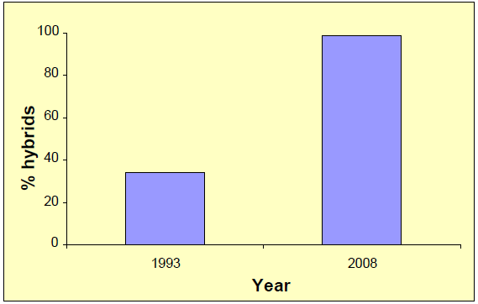
Fig. 8.9 The proportion of hybrids in the samples of DR and LSR whitefish from 1993 and 2008.

Climate change impacts
Current climate change scenarios constitute serious threats to freshwater ecosystems with projected effects on e.g. biodiversity, food webs and species interactions, ecosystem stability, pollution impacts, as well as fish production and exploitation and other important ecosystem services (Wrona et al. 2006, 2013, Jeppesen et al. 2010, Wilby et al. 2010). Most climate predictions stress that the Arctic is one of the global areas that are facing especially large changes (i.e. IPCC 2007, 2013). Freshwater systems may also be exposed to several environmental stressors including pollution, impoundments, landscape alterations, resource exploitation and biological invasions, which can reduce the robustness of the systems and synergistically enhance any degradation effects of climate change (Wrona et al. 2006). The sensitivity to climate change and other environmental perturbations is assumed to be particularly high in Arctic and subarctic freshwater systems (Prowse et al. 2006, Primicerio et al. 2007), but little is known about the possible effects and responses in terms of resilience and adaptability of these ecosystems. The most influential ecosystem drivers associated with climate change are temperature, precipitation and flow regimes, and biotic interactions (e.g. Wenger et al. 2011). Increased temperatures can increase growth and production if suitable resources are available, but may also change the interaction outcomes between species and result in changes in community composition and food web structure and functioning. Increased precipitation will in general increase the water-flow through the catchment area and may potentially increase element fluxes from the catchment area to the water body.

Pertinent time-series data are invaluable assets for the exploration of ecosystem effects of climate variability. In this respect, the availability of comprehensive long-term data sets from the Pasvik watercourse provides a unique basis for exploration and continued monitoring of relevant parameters. Three key objectives have been addressed: firstly, are there any significant changes to be seen in the temperature regime of the watercourse; secondly, are there any evidence of temperature effects upon growth achievements of fish (juvenile coregonids); and finally, are there any changes in the fish community composition that can be related to temperature induced changes in species interactions (with special emphasis on the community contribution of perch)?

Temperature changes in the Pasvik watercourse
The Norwegian Water Resources and Energy Directorate (NVE) has monitored the water temperatures in the Pasvik watercourse on a daily basis since 1991, based on a temperature logger installed at the Skogfoss hydropower station. Prior to 1991, there were no water temperature measurements in the system. However, Gjelland et. al. (2013) have estimated daily water temperature from observed air temperature, modifying a link model presented by Kvambekk and Ekker (2010) to obtain a new model developed specifically for the Pasvik watercourse. Data on the daily mean water temperatures from 2003 to 2008 were used to calibrate the new link model, which subsequently was tested and found to give good predictions of the water temperatures in the watercourse, with most predictions falling within ± 1 °C of the observed water temperatures from the Skogfoss temperature logger for the period from 1991 to 2011 (Gjelland et al. 2013).

Both observed (1991-2013, except 1998 when the temperature logger was not functioning) and estimated temperatures (1975-1990 + 1998) have been used to calculate average water temperatures during the main growing season for fish in the Pasvik watercourse (i.e., mean temperature over the combined July, August and September time period). Linear regression analyses were conducted to establish if there were any significant temperature changes during the explored time period. We found that average water temperature increased significantly from 1975 to 2013 with on average 0.05 °C/year (Fig. 8.10; F = 13 on 1 and 37 d.f., p<0.001). Over the 38 years, the average summer water temperature increased from 11.89 °C to 13.84 °C, i.e. an increase of 1.95 °C for the total period, equivalent to a mean temperature increase of 0.51 °C per decade.

Projections from the Special Report on Emissions Scenarios (SRES) are widely used for predictions of future climate change based on different scenarios for future human activity in respect to demographic, economic and technological developments and their resulting green-house gas emissions (IPCC 2001, 2007). By adopting the SRES A1B scenario, which is expected to give medium climate change responses, and by downscaling global climate models to provide regional predictions using the HIRHAM5 downscaled ECHAM A1B scenario, Gjelland et al. (2013) was able to make temperature, precipitation and runoff predictions for the Pasvik watercourse. According to these model predictions, the water temperature and length of the ice-free season will continue to increase throughout the 21 century (Gjelland et al. 2013), as will also the annual precipitation and runoff (Fig. 8.11). This sets the scene for potential large ecological changes in the watercourse, especially as i) the sensitivity to climate change and other environmental perturbations is assumed to be particularly high in Arctic and subarctic freshwater systems (Prowse et al. 2006, Primicerio et al. 2007), and ii) systems exposed to multiple environmental stressors are more susceptible to degradation effects of climate change (Wrona et al. 2006). Little information exists on how the limnetic ecosystems and organisms in Pasvik will react to perturbations. However, the implemented long-term studies provide a strong basis for future investigations, and some initial results have already been retrieved in respect to possible climate change impacts on the fish community in the watercourse.

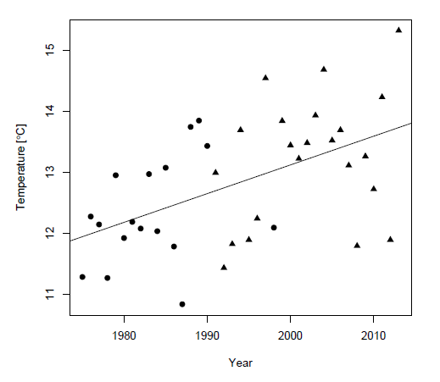
Fig. 8.10 Annual average summer water temperatures (the July, August and September period combined) in the Pasvik watercourse in the time period from 1975 to present. Circle = water temperatures estimated from air temperature, and triangle = observed water temperatures.

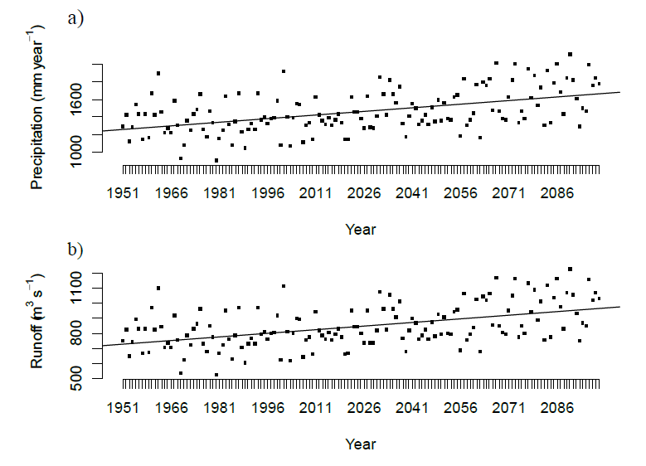
Fig. 8.11 Model predictions based on the HIRHAM5 downscaled ECHAM5 A1B scenario (ENSEMBLE data) of a) yearly average precipitation and b) mean runoff for the Pasvik-Inari watershed (trend lines are based on linear regression of the data). The mean runoff was estimated as precipitation subtracted by evaporation predicted by the same model. Note that this is an overestimate since evapotranspiration prediction data were not available for the applied model. From Gjelland et al. (2013).

Temperature dependent growth in juvenile coregonids
Growth in fish is affected by both abiotic and biotic factors, like e.g. water temperature and quality, and the density of prey, competitors and predators. Here, we have focused on how changes in summer water temperatures may affect the juvenile growth of the coregonids in the Pasvik watercourse. Temperature has a strong influence on the metabolism of organisms, and increased temperatures can increase growth and production if suitable resources are available. Individual fish growth is temperature-dependent, and may be reduced if respiration losses are greater than energy gains. The responses of the limnic system to climate change may thus be both positive and negative depending on characteristics of the ecosystem processes. Growth patterns may also change both life-history tactics (i.e. short-term ecological responses) and strategies (i.e. evolutionary changes). It is suggested that coregonid larval growth is primarily controlled by temperature and thereafter by food availability. Hence, a slight shift in temperature regime may potentially have a dramatic effect on growth of larval and juvenile coregonids (Eckmann and Rösch 1998; Perrier et al. 2012). Here, back-calculated length at age 1-yr (and thus the growth performance during the first year of life) of vendace and DR and LSR whitefish were matched to the corresponding summer water temperatures to explore possible climate and temperature effects on juvenile coregonid growth over an approx. 20 year time period.

The fish used in this study were sampled from Vaggatem and Skrukkebukta over the time period from 1991 to 2013. The fork length was determined to the nearest millimeter and otoliths were taken for aging and back-calculation measurements. A total of 265 vendace, 244 LSR whitefish and 266 DR whitefish were analyzed. Otoliths were photographed with a Zeiss AxioCam ERc5s, and otolith size measurements were conducted using the software from Zeiss. Length at age was then determined by using the Finstad model for back-calculation of growth (Finstad 2003), which is modified from Morita and Matsuishi’s (2001) back-calculation model:

L_{t} = [O_{t}O_{T}⁻¹(β₀ + β₁L_{T} + β₂T + β₃L_{T}T) – β₀ – β₂t] (β₁ + β₃t)-1 (Eq. 8.1),

where L_{t} is the back-calculated length at age t, T is the age at capture, O_{t} is the measured otolith radius at age t, O_{T} is the total otolith radius, L_{T} the observed fish length at the time of capture, and β₀ - β₃ are coefficients estimated by multiple linear regression of the length, age and otolith size relationship. The sampled coregonids had an age range from 2-7 years at the time of capture. For all fish, the back-calculated length at age 1-yr (i.e. one summer plus one winter old fish) was compared to the average summer temperature the preceding year using linear regression analyses.

The mean lengths combined for all years for 1-yr old venadace, DR and LSR whitefish were 81.1 mm, 65.8 mm and 69.3 mm, respectively. All three coregonid differed significantly from each other in length at age 1 (ANOVA, F=141.3, P<0.001). Between lake-differences (Vaggatem vs Skrukkebukta) in back-calculated length at age 1-yr was apparent for DR whitefish (t-test: t=-8.147, p<0.001) and LSR whitefish (t-test: t=-3.769, p<0.001), but not for vendace (t-test: t=1.0155, p=0.3108). The length at age 1-yr was also for all three morphs dependent on the mean water temperature from the previous summer (Fig. 8.12). The estimated mean lengths of 1 year old vendace, DR and LSR whitefish increased with increasing temperature by 2.1 mm/°C (F=13.04 on 1 and 264 d.f., p<0.001), 2.6 mm/°C (F=10.59 on 1 and 265 d.f., p=0.0013) and 4.6 mm/°C (F=27.35 on 1 and 243 d.f., p<0.001), respectively (Fig. 8.12).

From the present findings, it seems evident that an increase in temperature will increase larval and juvenile growth in the three coregonids in the Pasvik watercourse. The temperature-dependent growth effect acts differently between the three groups of coregonids in this study, as e.g. the length of the LSR-whitefish morph increased the most with increasing water temperature. However, the average summer water temperature may seem to have reached a threshold limit for optimal growth for whitefish, which has a lower temperature optimum for growth than vendace (cf. Eckmann and Rösch 1998; Tapaninen et al. 1998), and an even further increase in water temperature in the future will therefore likely benefit vendace. Thus, although the present temperature regime in the Pasvik watercourse may be favorable for the juvenile growth rate of the LSR whitefish morph, the expected future increase in temperatures will likely shift the favorability towards vendace. Hence, as vendace and DR whitefish compete strongly for the pelagic resources and since a further increase in water temperatures likely will be favorable for the vendace, the outcome may be an even stronger negative effect on the DR whitefish population. However, between-lake differences in fish length at age 1-yr for the whitefish morphs also suggest that other factors than temperature (like e.g. food resource availability) are important for the growth at the juvenile and larval stages.

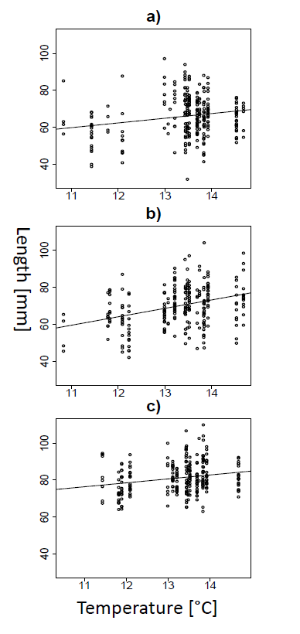
Fig. 8.12 Length at different summer average temperatures for DR whitefish (a), LSR whitefish (b) and vendace (c) at age 1-yr.

Climate change impacts on the fish community contribution of perch
Climate warming is expected to induce complex changes in fish community structure (Jeppesen et al. 2010, Angert et al. 2013). Ecological interactions are likely instrumental in this respect, as e.g. temperature changes will affect species in a community differently and thus likely alter the outcome of species interactions (Gilman et al. 2010, Dell et al. 2014). Fish species may be classified into thermal ‘guilds’ depending on their adaptation to different water temperatures (Magnuson et al. 1979; Hayden et al. 2014). Within the Fennoscandian freshwater fish assemblage, whitefish and perch can be classified as cold- and cool-water adopted species, respectively (Hayden et al. 2014). Whitefish is a cold-water stenothermic species with optimum growth at 18 ºC (Siikavuopio et al. 2013), whereas perch is a cool-water eurythermic species with optimum growth at 23 ºC (Fiogbe & Kestemont 2003). Hence, perch is considered as the species that most likely will benefit from increasing temperatures at the expense of e.g. whitefish (Graham & Harrod 2009; Hayden et al. 2014).

To explore possible impacts on fish community composition of the revealed water temperature increase in the Pasvik watercourse, our long-term data set has been analyzed in respect to the contribution of perch in the littoral habitat (Fig. 8.13). In Vaggatem, there were large inter-annual variations in the contribution of perch, with an overall weak, but non-significant increase in its proportion to the catches over the period from 1991 to 2013 (Linear regression analysis; r²=0.13, p=0.12). However, a significant increase occurred over the first part of the study period from a contribution of ca. 20% in 1991 to 50-60% around 2003 (r²=0.60, p<0.01), followed by a period of no significant changes up to 2013 (r²=0.02, p=0.67). In Skrukkebukta, the development pattern of the littoral fish community was very clear-cut with a distinct and significant increase in the perch contribution from 1993 to 2013, from around 5% in the start to nearly 50% at the end of the study period (r²=0.75, p<0.001). Hence, in concordance with the observed increase in water temperatures over the recent decades, there has seemingly also been a large increase in the contribution of perch to the littoral fish communities in the watercourse, suggesting that perch may have benefitted from the increasing temperatures. A similar increase in the contribution of perch has also been documented in fish communities of several smaller lakes in this region (see details under Activity 5), which strongly support that this is an effect of the current climate changes.

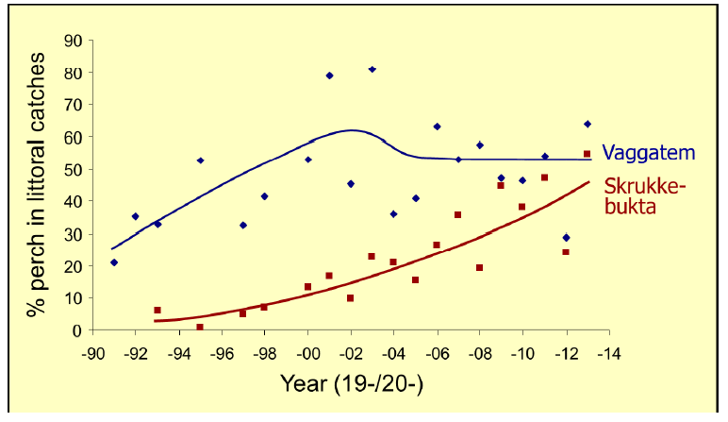
Fig. 8.13 The contribution of perch (with fitted trend lines) in littoral samples from Vaggatem and Skrukkebukta in the time period from 1991 to 2013.

Climate impact conclusions
In essence, the present findings demonstrate that climate change impacts already are in effect in the Pasvik watercourse, having induced a significant increase in the mean summer water temperatures over the last decades and seemingly also induced important ecological responses and effects. In particular, it has been demonstrated that the juvenile growth of the coregonids is significantly impacted by the increased water temperatures, which potentially may affect their interspecific interactions. Furthermore, a change in the fish community composition of the littoral zone is also evident, with an increase in the contribution of perch which most likely is related to the observed temperature increases. Additionally, there has been an increase in the contamination levels of Hg in fish over the latest years which suggestively is a climate change consequence related to increased precipitation and runoff. The multitude of stressors affecting the Pasvik watercourse may enhance potential climate change impacts in the watercourse, making the ecosystems less resistant and thus more vulnerable to the induced changes. However, more work is needed to confirm these patterns and to explore the mechanisms and possible consequences of the increasing climate change impacts on the watercourse, especially since these are occurring in concert with other several other stressors, including pollution, water impoundments and biological invasions.

References

Amundsen, P.-A., Staldvik, F.J., Lukin, A.A., Kashulin, N.A., Popova, O.A. & Reshetnikov, Y.S. 1997. Heavy metal contamination in freshwater fish from the border region between Norway and Russia. Sci. Total Env. 201: 211-224.
Amundsen, P.-A., Staldvik, F.J., Reshetnikov, Y.S., Kashulin, N., Lukin, A., Bøhn, T., Sandlund, O.T. & Popova, O.A. 1999. Invasion of vendace (Coregonus albula) in a subarctic watercourse. Biol. Conserv. 88: 405-413.
Amundsen, P.-A., Bøhn, T., Popova, O.A., Staldvik, F.J., Reshetnikov, Y.S., Lukin, A.A. & Kashulin, N.A. 2003. Ontogenetic niche shifts and resource partitioning in a subarctic piscivorous fish guild. Hydrobiologia 497: 109-119.
Amundsen, P.-A., Kashulin, N.A., Gjelland, K.Ø., Sandimirov, S.S., Jensen, H., Shirokov, V. A., Kudrevtcheva, L.P., Bøhn, T. & Aspholm, P.E. 2004. Brown trout in the Pasvik watercourse: population status and potentials and limitations for recruitment, production and management. Report, NFH, University of Tromsø & INEP, Kola Science Centre. 41 pp.
Amundsen, P.-A., Kashulin, N.A., Koroleva, I.M., Gjelland, K.Ø., Lien, C., Terentjev, P.M., Dalsbø, L., Sandimirov, S.S., Kudryavtcheva, L.P. & Knudsen, R. 2006. Environmental monitoring of fish in the Inari-Paz watercourse. Report, Norwegian College of Fishery Science, University of Tromsø & Institute of North Industrial Ecology Problems, Kola Science Centre. 88 pp.
Amundsen, P.-A., Siwertsson, A., Primicerio, R. & Bøhn, T. 2009. Long-term responses of zooplankton to invasion by a planktivorous fish in a subarctic watercourse. Freshw. Biol. 54: 24-34.
Amundsen, P.-A., Kashulin, N.A., Terentjev, P., Gjelland, K.Ø., Koroleva, I.M., Dauvalter, V.A., Sandimirov, S., Kashulin, A. & Knudsen, R. 2011. Heavy metal contents in whitefish (Coregonus lavaretus) along a pollution gradient in a subarctic watercourse. Environm. Monitor. Assessm. 182: 301-316.
Amundsen, P.-A., Salonen, E., Niva, T., Gjelland, K.Ø., Præbel, K., Sandlund, O.T., Knudsen, R. & Bøhn, T. 2012. Invader population speeds up life history during colonization. Biol. Invasions 14: 1501-1513.
Arnesen, A.-M. 1987. Utsettinger av ørret i Pasvikelva 1979 – 1986. Fylkesmannen i Finnmark, Miljøvernavdelingen. Rapport nr. 26. 22 p. (In Norwegian)
Aspholm, P. 2013. Historisk informasjon om forekomster av elvemusling Margaritifera margaritifera i forhold til kjente nåværende bestander i Finnmark. Bioforsk Rapport 8 (115). 28 p. (In Norwegian)
Bhat, S., Amundsen, P.-A., Knudsen, R., Gjelland, K.Ø., Fevolden, S.-E, Bernatchez, L. & Præbel, K. 2014. Speciation reversal in European whitefish (Coregonus lavaretus (L.)) caused by competitor invasion. PLOS ONE 9(3): e91208.
Bjerknes, V. & Rikstad, A. 1977. Fiskeribiologiske forhold i den norske del av Pasvikvassdraget. Fiskerikonsulenten i Finnmark. Rapport nr 7. 31 pp. (In Norwegian)
Boecklen, W.J., Yarnes, C.T., Cook, B.A. & James, A.C. 2011. On the use of stable isotopes in trophic ecology. Ann. Rev. Ecol. Evol. Systemat. 42: 411–440.
Bøhn, T. & Amundsen, P.-A. 1998. Effects of invading vendace (Coregonus albula) on species composition and body size in two zooplankton communities of the Pasvik River System, Northern Norway. J. Plankton Res. 20: 243-256.
Bøhn, T. & Amundsen, P.-A. 2001. The competitive edge of an invading specialist. Ecology 82: 2150-2163.
Bøhn, T. & Johansen, M. 2003. Laks med livets rett i Pasvik? Prosjektrapport, Norges Fiskerihøgskole, Universitetet i Tromsø. 24 p. (In Norwegian)
Bøhn, T., Amundsen, P.-A., Popova, O. A., Reshetnikov, Y. S. & Staldvik, F. J. 2002. Predator avoidance by coregonids: Can habitat choice be explained by size-related prey vulnerability? Advanc. Limnol. 57:183-197: 2002.
Bøhn, T., Sandlund, O.T., Amundsen, P.-A. & Primicerio, R. 2004. Rapidly changing life history during invasion. Oikos 106: 138-150.
Bøhn, T., Amundsen, P.-A. & Sparrow, A. 2008. Competitive exclusion after invasion? Biol. Invasions 10: 359-368.
Castello, L. et al. 2013. Low and declining mercury in Arctic Russian rivers. Environ. Sci. & Technol. 48: 747−752.
Dell, A.I., Samraat, S. & Van M. Savage, V.M. 2014. Temperature dependence of trophic interactions are driven by asymmetry of species responses and foraging strategy. J. Anim. Ecol. 83: 70–84.
Eckmann, R. & Rösch, R. 1998. Lake Constance fisheries and fish ecology. Advanc. Limnol. 53: 285–301.
Evans, M.L., Præbel, K., Peruzzi, S., Amundsen, P.-A. & Bernatchez, L. 2014. Phenotype-environment association of the oxygen transport system in trimorphic European whitefish (Coregonus lavaretus) populations. Evolution, in press.
Finstad, A.G. 2003. Growth backcalculations based on otoliths incorporating an age effect: adding an interaction term. J. Fish Biol. 62: 1222-1225.
Fiogbe, E. D. & Kestemont, P. 2003. Optimum daily ration for Eurasian perch Perca fluviatilis L. reared at its optimum growing temperature. Aquaculture 216:243–252.
Gilman, S.E., Urban, M.C., Tewksbury, J., Gilchrist, G.W. & Holt, R.D. 2010. A framework for community interactions under climate change. TREE 25: 325–331.
Gjelland, K.Ø., Finstad, A.G., Amundsen, P.-A., Christensen, G. & Jensen, H. 2013. Limnosystem Pasvik (LIPA) observation system – report from the 2012 pilot project. NINA Minirapport 429. 24 p.
Graham, C. T. & Harrod, C. 2009. Implications of climate change for the fishes of the British Isles. J. Fish Biol. 74: 1143–1205.
Harris, R.C. et al. 2007. Whole-ecosystem study shows rapid fish-mercury response to changes in mercury deposition. PNAS 104: 16586–16591.
Hayden, B., Harrod, C. & Kahilainen, C. 2014. Lake morphometry and resource polymorphism determine niche segregation between cool- and cold-water-adapted fish. Ecology 95: 538–552.
IPCC 2000. Special Report on Emissions Scenarios. N. Nakicenovic and R. Swart (Eds). Cambridge University Press, UK. 570 pp.
IPCC 2007. Climate Change 2007: Synthesis Report. Contribution of Working Groups I, II and III to the Fourth Assessment Report of the Intergovernmental Panel on Climate Change [Core Writing Team, Pachauri, R.K and Reisinger, A. (eds.)]. IPCC, Geneva, Switzerland, 104 pp.
IPCC 2013. Climate Change 2013: The Physical Science Basis. Contribution of Working Group I to the Fifth Assessment Report of the Intergovernmental Panel on Climate Change [Stocker, T.F., D. Qin, G.-K. Plattner, M. Tignor, S.K. Allen, J. Boschung, A. Nauels, Y. Xia, V. Bex and P.M. Midgley (eds.)]. Cambridge University Press, Cambridge, United Kingdom and New York, NY, USA, 1535 pp.
Jensen, H., Bøhn, T., Amundsen, P.-A. & Aspholm, P.E. 2004. Feeding ecology of piscivorous brown trout (Salmo trutta L.) in a subarctic watercourse. Ann. Zool. Fennici 41: 319-328.
Jensen, H., Amundsen, P.-A, Elliott, J.M., Bøhn, T., & Aspholm, P.E. 2006. Prey consumption rates and growth of piscivorous brown trout in a subarctic watercourse. J. Fish Biol. 68: 838-848.
Jensen, H., Kahilainen, K.K., Amundsen, P.-A., Gjelland, K.Ø., Tuomaala, A., Malinen, T., & Bøhn, T. 2008. Predation by brown trout (Salmo trutta) along a diversifying prey community gradient. Can. J. Fish. Aquat. Sci. 65: 1831-1841.
Jeppesen, E., et al. 2010. Impacts of climate warming on lake fish community structure and potential effects on ecosystem function. Hydrobiologia 646: 73–90.
Kahilainen, K., Siwertsson, A., Gjelland, K.Ø., Knudsen, R., Bøhn, T., & Amundsen, P.-A. 2011a. The role of gill raker number variability in adaptive radiation of coregonid fish. Evol. Ecol. 25: 573-588.
Kahilainen, K., Østbye, K., Harrod, C., Shikano, T., Malinen, T. & Merilä, J. 2011b. Species introduction promotes hybridization and introgression in Coregonus: is there sign of selection against hybrids? Mol. Ecol. 20: 3838–3855.
Kashulin, N.A., Terentyev, P.M., Amundsen, P.-A., Dauvalter, V.A., Sandimirov, S.S. & Kashulin, A.N. 2011. Specific features of accumulation of Cu, Ni, Zn, Cd, and Hg in two whitefish Coregonus lavaretus (L.) morphs inhabiting the Inari–Pasvik lacustrine–riverine system. Inland Water Biol. 4: 383-392.
Kristoffersen, K. 1984. Fiskeribiologiske registreringer i Pasvikvassdraget sommeren 1982. Fylkesmannen i Finnmark, Miljøvernavdelingen. Rapport nr. 5. 66 p. (In Norwegian)
Kvambekk, Å.S. and Ekker, R. 2010. Klimascenarioer og scenarioer for vannføring og temperatur i ferskvann. In Atlantic salmon in future climates: Rewiew of current knowlegde and scenarios with focus on water discharge and temperature (edited by Finstad, A.G.). NINA Report 646, p. 15-32.
Layman, C.A., Araújo, M.S., Boucek, R., Hammerschlag-Peyer, C.M., Harrison, E., Jud, Z.R. et al. (2012) Applying stable isotope to examine food-web structure: an overview of analytical tools. Biol. Rev. 87: 545–532.
Liso, S., Gjelland, K.Ø., Reshetnikov, Y. & Amundsen, P.-A. 2011. A planktivorous specialist turns rapacious – piscivory in invading vendace (Coregonus albula). J. Fish Biol. 78: 332-337.
Magnuson, J. J., Crowder, L. B. & Medvick, P. A. 1979. Temperature as an ecological resource. Amer. Zool. 19: 331–343.
Mooney H. A. & Hobbs, R. J. 2000. Invasive species in a changing world. Island Press, Washington, D.C., USA.
Morita, K., & Matsuishi, T. 2001. A new model of growth back-calculation incorporating age effect based on otoliths. Can. J. Fish.Aquat. Sci. 58: 1805-1811.
Mutenia, A. & Salonen, E. 1992. The vendace (Coregonus albula L.), a new species in the fish community and fisheries of Lake Inari. Polish Arch. Hydrobiol. 39: 797-805.
Perrier, C., Molinero, J. C., Gerdeaux, D. & Anneville, O. 2012. Effects of temperature and food supply on the growth of whitefish Coregonus lavaretus larvae in an oligotrophic peri‐alpine lake. J. Fish Biol. 81: 1501-1513.
Post, D.M. 2002. Using stable isotopes to estimate trophic position: models, methods, and assumptions. Ecology 83: 703–718.
Primicerio, R., Rossetti, G., Amundsen, P.-A. & Klemetsen, A. 2007. Impact of climate change on Alpine and Arctic lakes: effects on phenology and community dynamics. In: Arctic Alpine Ecosystems and People in a Changing Environment (J.B. Ørbæk et al., eds.). Springer Verlag, Berlin, 51-70.
Prowse, T.D., Wrona, F.J., Reist, J.D., Gibson, J., Hobbie, J., Lévesque, L. & Vincent, W.F. 2006. Climate change effects on hydroecology of arctic freshwater ecosystems. Ambio 35: 347-358.
Præbel, K., Gjelland, K.-Ø., Salonen, E. & Amundsen, P.-A. 2013a. Invasion genetics of vendace (Coregonus albula (L.)) in the Inari-Pasvik watercourse: revealing the origin and expansion pattern of a rapid colonization event. Ecol. Evol. 3, 1400-1412.
Præbel, K., Knudsen, R., Siwertsson, A., Karhunen, M., Kahilainen, K., Ovaskainen, O., Ostbye, K., Peruzzi, S., Fevolden, S.-E., & Amundsen, P.-A. 2013b. Ecological speciation in postglacial European whitefish: rapid adaptive radiations into the littoral, pelagic and profundal lake habitats. Ecol. Evol. 3, 4970-4986.
Riget, F. et al. 2011. Temporal trends of Hg in Arctic biota, an update. Sci. Total Environ. 409: 3520−3526.
Salonen, E. 1998. The vendace stock and fisheries in Lake Inari. Bor. Env. Res. 3, 307-319
Salonen, E. 2004. Estimation of vendace year-class strength with different methods in the subarctic Lake Inari. Ann. Zool. Fennici 41, 249-254.
Salonen, E., Amundsen, P-A. & Bøhn, T. 2007. Invasion, boom and bust by vendace (Coregonus albula) in the subarctic Lake Inari, Finland and the Pasvik watercourse, Norway. Advanc. Limnol. 60: 331-342.
Sandlund O. T., Schei, P.J. & Viken, Å. (eds.) 1999. Invasive species and biodiversity management. Kluwer Academic Publishers, Dordrecht, The Netherlands.
Sandlund, O.T., Gjelland, K.Ø., Bøhn, T., Knudsen, R. & Amundsen, P.-A. 2013. Contrasting life history responses of a young morph-pair of European whitefish to the invasion of a specialised coregonid competitor, vendace. PLOS One 8 (7), e68156.
Siikavuopio, S.I., Knudsen, R., Amundsen, P.-A., Sæther, B.S. & James, P. 2013. Effects of high temperature on the growth of European whitefish (Coregonus lavaretus L.). Aquacult. Res. 44: 8-12.
Siwertsson, A., Knudsen, R., Kahilainen, K.K., Præbel, K., Primicerio, R. & Amundsen, P.-A. 2010. Sympatric diversification influenced by ecological opportunity and historical contingency in a young species lineage of whitefish. Evol. Ecol. Res. 12, 929-947.
Syväranta, J., Hämäläinen, H. & Jones, R.I. 2006. Within-lake variability in carbon and nitrogen stable isotope signatures. Freshw. Biol. 51: 1090-1102.
Tapaninen, M., Marjomäki, T. J. & Keskinen, T. 1998. The seasonal final temperature preferenda of immature vendace, Coregonus albula (L.). Ergebnisse der Limnologie 50: 131-141.
Vander Zanden, M.J. & Rasmussen, J.B. 1999. Primary consumer δ¹³C and δ¹⁵N and the trophic position of aquatic consumers. Ecology 80: 1395-1404.
Wenger, S.J., Isaak, D.J., Luce, C.H., Neville, H.M., Fauch, K.D., Dunham, J.B., Dauwalter, D.C., Young, M.K., Elsner, M.M., Rieman, B.E., Hamlet, A.F. & Williams, J.E. 2011. Flow regime, temperature, and biotoc interactions drive differential declines of trout species under climate change. PNAS 108: 14175-14180.
Wilby, R.L. et al. 2010. Evidence needed to manage freshwater ecosystems in a changing climate: Turning adaptation principles into practice. Sci. Tot. Env. 408: 4150-4164.
WRI/IUCN/UNEP 1992. Global Biodiversity Strategy. Guidelines for Action to Save, Study, and Use Earth's Biotic Wealth Sustainably and Equitably. WRI, IUCN & UNEP, Washington, D.C., Gland, Switzerland, & Nairobi, Kenya.
Wrona, F.J, Prowse, T.D., Reist, J.D., Hobbie, J.E., Lévesque, L.M.J. & Vincent, W.F. 2006. Climate change effects on aquatic biota, ecosystem structure and function. Ambio 35: 359-369.
Wrona, J.F., Reist, J.D., Amundsen, P.-A. et al. 2013. Freshwater ecosystems. Chap. 13, p. 325-367 in: Arctic Biodiversity Assessment report. CAFF.

